TASK 5:
#include <stdio.h>

void swap(int *a,int *b){
int t=*a;
*a=*b;
*b=t;
}
int main(){
int x=7,y=17;
printf("Before swap: x=%d y=%d\n",x,y);
swap(&x,&y);
printf("After swap: x=%d y=%d\n",x,y);
return 0;
}
OUTPUT:
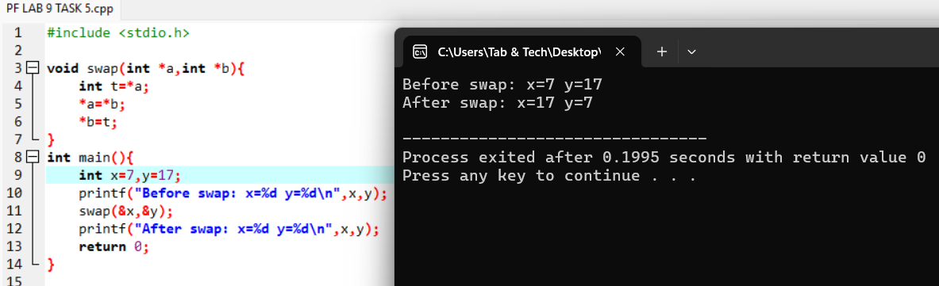

TASK 6:
#include <stdio.h>

void calculate(int a,int b,int *sum,float *avg){
*sum=a+b;
*avg=(float)*sum/2;
}
int main(){
int n1=7,n2=2,s;
float a;
calculate(n1,n2,&s,&a);
printf("Sum=%d\n",s);
printf("Avg=%.2f\n",a);
return 0;
}
OUTPUT:
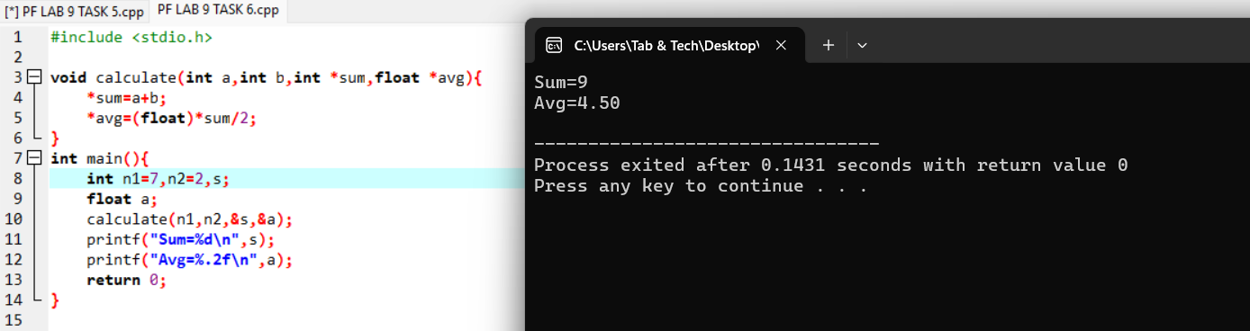
TASK 7:
#include <stdio.h>
int main(){
int *p=NULL;
if(p==NULL){
printf("Pointer not pointinG any valid memory\n");
}else{
printf("Pointer is valid\n");
}
return 0;
}
OUTPUT:
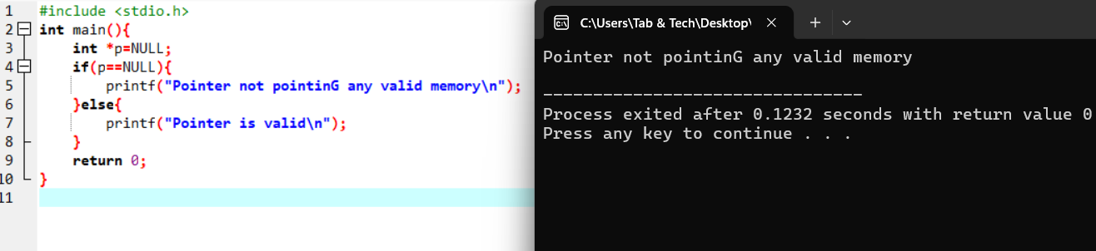

TASK 8:
#include <stdio.h>

int main(){
int a=24;
float b=5.10;
char c='U';
void *ptr;

ptr=&a;
printf("int: %d\n",*(int*)ptr);

ptr=&b;
printf("float: %.1f\n",*(float*)ptr);

ptr=&c;
printf("char: %c\n",*(char*)ptr);
return 0;
}

OUTPUT:
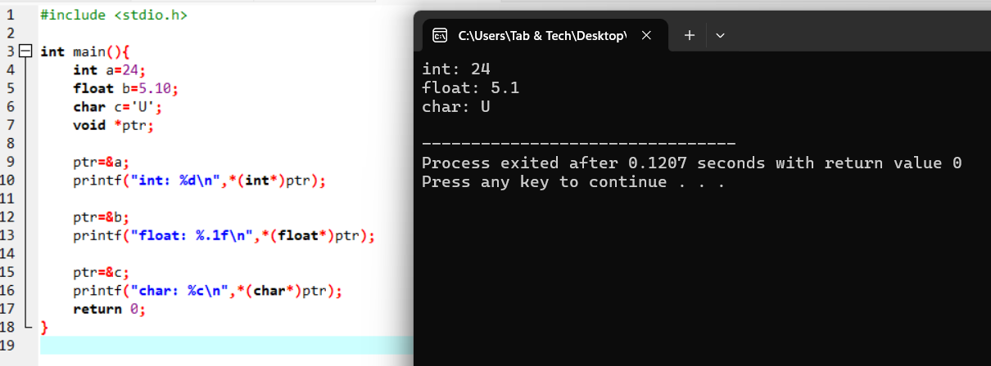

TASK 9:
#include <stdio.h>

int add(int a,int b){ return a+b; }
int sub(int a,int b){ return a-b; }
int mul(int a,int b){ return a*b; }
int divi(int a,int b){ return b!=0 ? a/b : 0; }

int main(){
int x,y,op;
int (*fp)(int,int);
printf("Enter 2 nums: ");
scanf("%d%d",&x,&y);
printf("1.Add 2.Sub 3.Mul 4.Div\n");
scanf("%d",&op);

if(op==1) fp=add;
else if(op==2) fp=sub;
else if(op==3) fp=mul;
else if(op==4) fp=divi;
else { printf("Invalid\n"); return 0; }

printf("Result=%d\n",fp(x,y));
return 0;
}
OUTPUT:
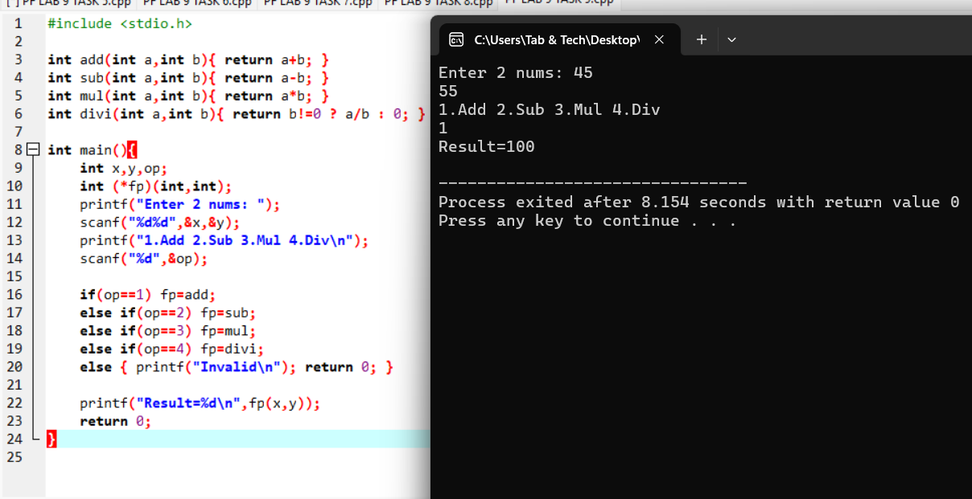
TASK 10:
#include <stdio.h>

float average(int a,int b,int c){
return (a+b+c)/3.0;
}
int main(){
int n1=9,n2=5,n3=14;
float r=average(n1,n2,n3);
printf("Average=%.2f\n",r);
return 0;
}
OUTPUT:
